Hybrid Cloud

🌉 Definition of Hybrid Cloud
# Source: AI Source: Provided by: [Data Path: Persons Table -> ID Column: 1, Name_En Column: Motasem Essam] -> From: [ChatGPT] on [1/26/2026]
A Hybrid Cloud is a cloud computing model that combines Public Cloud and Private Cloud environments, allowing data and applications to be shared between them. This approach provides flexibility, scalability, and control by leveraging the strengths of both models.
Key points:
- Integrates private and public cloud resources.
- Supports workload portability, allowing applications to move between clouds as needed.
- Ideal for organizations that want scalability without compromising security or compliance.

⚙️ Features of Hybrid Cloud
# Source: AI Source: Provided by: [Data Path: Persons Table -> ID Column: 1, Name_En Column: Motasem Essam] -> From: [ChatGPT] on [1/26/2026]
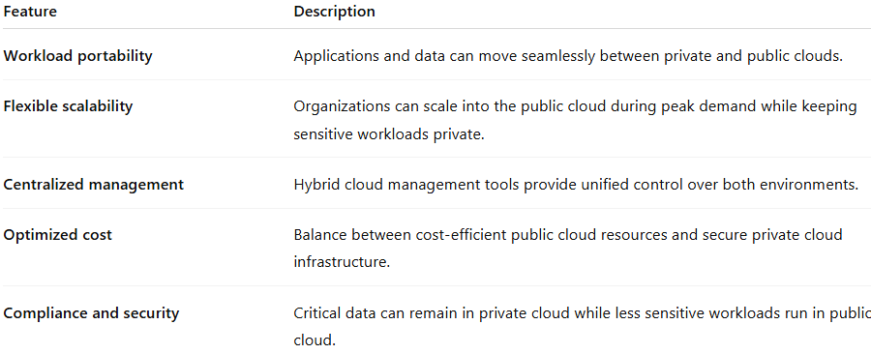
Feature | Description
Workload portability | Applications and data can move seamlessly between private and public clouds.
Flexible scalability | Organizations can scale into the public cloud during peak demand while keeping sensitive workloads private.
Centralized management | Hybrid cloud management tools provide unified control over both environments.
Optimized cost | Balance between cost-efficient public cloud resources and secure private cloud infrastructure.
Compliance and security | Critical data can remain in private cloud while less sensitive workloads run in public cloud.

✅ Advantages of Hybrid Cloud
# Source: AI Source: Provided by: [Data Path: Persons Table -> ID Column: 1, Name_En Column: Motasem Essam] -> From: [ChatGPT] on [1/26/2026]
- Best of both worlds: Combines scalability and cost-effectiveness of public cloud with security and control of private cloud.
- Flexible workload placement: Move workloads to the optimal environment based on cost, performance, and compliance needs.
- Business continuity: Supports disaster recovery and high availability.
- Cost optimization: Use public cloud for variable workloads while keeping predictable workloads in private cloud.
- Faster innovation: Leverage public cloud services for testing and development without affecting private infrastructure.

⚠️ Disadvantages / Challenges
# Source: AI Source: Provided by: [Data Path: Persons Table -> ID Column: 1, Name_En Column: Motasem Essam] -> From: [ChatGPT] on [1/26/2026]
- Complex management: Requires sophisticated monitoring and orchestration tools.
- Integration difficulties: Ensuring seamless connectivity and compatibility between clouds can be challenging.
- Security considerations: Must maintain consistent security policies across multiple environments.
- Higher upfront cost: Initial setup of hybrid architecture may be expensive.

🛠️ Hybrid Cloud Use Cases
# Source: AI Source: Provided by: [Data Path: Persons Table -> ID Column: 1, Name_En Column: Motasem Essam] -> From: [ChatGPT] on [1/26/2026]
- Cloud bursting: Scale into public cloud during peak demand while maintaining core operations in private cloud.
- Regulated industries: Keep sensitive data in private cloud while using public cloud for analytics or less sensitive workloads.
- Development and testing: Use public cloud for agile development and private cloud for production workloads.
- Disaster recovery and backup: Replicate private cloud data to public cloud for backup and failover.

🌐 Examples of Hybrid Cloud Solutions
# Source: AI Source: Provided by: [Data Path: Persons Table -> ID Column: 1, Name_En Column: Motasem Essam] -> From: [ChatGPT] on [1/26/2026]
- Microsoft Azure Arc – extends Azure services to on-premises and multi-cloud environments.
- AWS Outposts – brings AWS infrastructure and services to on-premises data centers.
- Google Anthos – manages applications across on-premises and multiple clouds.
- VMware Cloud on AWS – integrates VMware private cloud infrastructure with AWS public cloud.

📌 Summary
# Source: AI Source: Provided by: [Data Path: Persons Table -> ID Column: 1, Name_En Column: Motasem Essam] -> From: [ChatGPT] on [1/26/2026]
The Hybrid Cloud combines the security and control of a private cloud with the scalability and cost-efficiency of a public cloud. It enables workload portability, cost optimization, and compliance flexibility, making it ideal for organizations with mixed requirements. Hybrid cloud solutions include AWS Outposts, Azure Arc, Google Anthos, and VMware Cloud on AWS, supporting both development agility and enterprise-level operations.

